IOT Asset tracking System

The GPS systems are todays most well known location tracking systems. Well these systems are not capable of pinpointing exact locations or locations of an entity within a building or on a particular floor or room. So here we propose a smart asset tracking system that allows to track location of objects, goods, personnel within a building or any facility. Our proposed system makes use of rf technology along with IOT to achieve this system. The system has the capability to pinpoint the location of any entity to exact room it is currently located in. The system uses mini rf circuits to be used as tracking devices. We use tracking microcontroller based circuits to track those rf circuits. The tracker cuircuits are battery powered circuits to be mounted on objects/entities. The monitoring circuits are to be placed in individual rooms. Now as soon as any tracker objects enter any room the tracker circuits come in 2-3 meters range of the monitoring circuit for that room. The monitoring system now transmits the location of that tracker circuit to the online system. We here use IOTGecko to handle the IOT tracking part. The transmitted data is now displayed by IOTGecko to pinpoint which room a particular object/entity is located in.

Block Diagram:
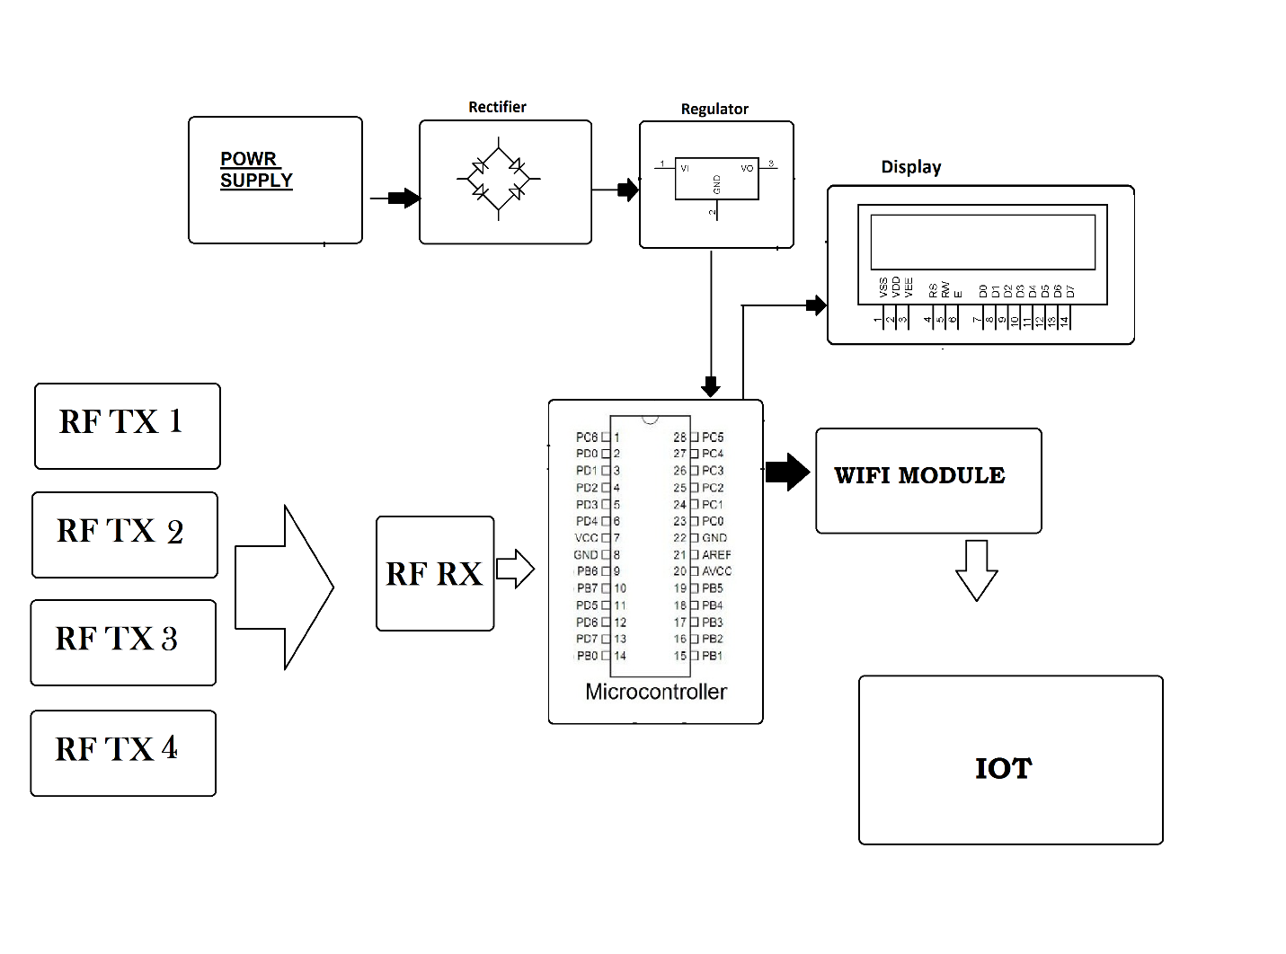

Hardware Specifications
- Power Supply
- Rectifier
- Regulator
- LCD
- wifi module
- Atmega Microcontroller
- Wifi Module
- 4 Rf Transmitters
- 2 Rf Receivers
- Resistors
- Capacitors
- Diodes

Software Specifications
- Python compiler
- Programming Language: Python
- IOTGecko

